(Approx. 677 words)

Scam Phone Calls Don't Have to Drive You Crazy
By Kurt Jefferson, Editor, Central Kentucky Computer Society
https://ckcs.org/
lextown2 (at) gmail.com

Years from now, when future generations look back on this era, they'll probably shake their heads and wonder about all the bothersome phone calls many of us receive and wonder why we put up with this nonsense.

While there is no silver bullet, you can block most of these calls by using software designed to block annoying robocalls, telemarketers, and phone scams.

You install the software on your iPhone or Android phone.

If you use a landline phone that receives calls using the Internet (called VoIP), many of these same products offer websites where you can tell your Internet provider to block unwanted calls.

The tech site, Mashable, lists seven of what it calls "The best robocall blocking apps and tools for avoiding phone spam." In other words, "Your jig is up, unknown caller!"

Here are Mashable's Top 7 Picks:

- Best Free App: Hiya – Caller ID & Spam Blocker

- Best Paid App: Nomorobo Robocall Blocking

- Best For Getting Revenge on Scammers: RoboKiller – Spam Call Blocker

- Best For Businesses: YouMail Voicemail and Spam Block

- Best For Landlines: Call Control Home

- Best For Number Lookups: Truecaller

- Best For Unmasking Calls: TrapCall – Reveal No Caller ID

The Mashable writer begins, "If there's one thing people with iPhones and Android phones can agree on, it's this: Robocalls suck. Although, personally speaking, robots call me more than my mother does…"

"At present, robocalls are the No. 1 source of consumer complaints to the FCC, making up 60% of all filings… Anyone can run a phone scan nowadays; one Florida man managed to place 96 million robocalls all by himself over three months in 2016 before the government cracked down on his shenanigans," add Mashable.

What I find scary is that in 2020 one in six Americans fell prey to scams, up from one in ten in 2017. The call-blocking company, Truecaller, discovered that each victim reported an average loss of $244.

Ouch. "Installing a third-party robocall blocking app remains one of the best and most reliable ways to prevent robocallers, telemarketers, and even pesky political campaigns from reaching you on your smartphone. (Be sure to do your due diligence and pore over its privacy policy first, so you know exactly what you're signing up for.)." writes Mashable.

A couple of CKCS members asked me what I use, and I mentioned Nomorobo. I use it on my iPhone and Ooma, the landline phone service at home (that's what CKCS uses at the office.)

Nomorobo got its start in 2012 when the Federal Trade Commission
put out a challenge. What became Nomorobo tied for the best overall solution, winning a $25,000 prize. You can download the smartphone app from the various app stores ($1.99 per month, per device) or register for the landline service (free) from the Nomorobo website. Scroll down, and you'll see Landlines and Mobile displayed at the bottom of the page.

As I type this on a rainy Monday afternoon in late October, Nomorobo is currently blocking more than 4.6 million scam phone calls. I got two scam phone calls this morning while walking in a park near my home. Nomorobo did its job – silencing both calls, so they never bothered me, and one went directly to voicemail trying to sell me an extended car warranty (one of the most pervasive and hated robocalls.)

The Nomorobo app as it appears on my iPhone in late October. If I get a possible scam call that is not in Nomorobo's database, I have the option of sending the phone number through the app to the Nomorobo staff for it to confirm it's bogus and add it to the giant database.

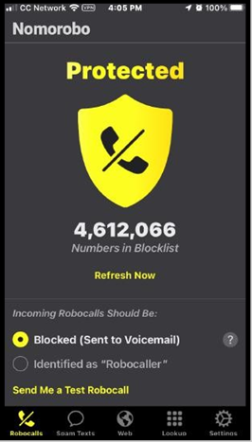
The Nomorobo app as it appears on my iPhone in late October. If I et a possible scam call that is not in Nomorobo's database, I have the option of sending the phone number through the app to the Nomorobo staff to confirm it's bogus and add it to the giant database.

